Design of Experiments for Checking Paint Adhesion

Somesh Pratap Singh

# Introduction

Design of experiments is a powerful technique to extract most information out of the resources available with you to conduct experiments. When we have less resources (physical, time and space), the technique would select various permutations of the input variables to record the independent and interactive dependence of the output on input parameters.

One of the major problems in statistical data modeling is passive data collection. While observed changes in individual factors (process variables) may be linked with changes in a response variable, they are not always the direct cause of those changes.It may be challenging to separate interactions into individual effects when different variables are changing simultaneously. In DOE, the data-generating process is actively changed to enhance the information's quality and get rid of repeated data.

For our study, we have three input variables

1. Number of passes: A quantitative variable. Can take continuous values between [1,25].
2. Speed (mm/s): Quantitative variable. Can take continuous values between [1,15].
3. SOD: Qualitative variable. Takes values as 13mm and 6.5mm.

# Screening methods

When we do the design of experiments, in the starting we might have many variables. Not all the variables are ‘critical to quality’, i.e., they do not affect the output in a very big significant manner. So, in the first stage we do a set of experiments to figure out the parameters (generally we end up having 3 to 4 factors which are important) that are ‘critical to quality’. In this stage of experiment, the parameters are generally treated on two levels and then their effect on the output is found out. The ones having low affect on the output are eliminated in the subsequent stages of study.

Following are some of the most popular screening techniques used in Design of Experiments:

1. Full Factorial Design
2. Fractional Factorial Design
3. Plackett-Burman Design
4. Foldover designs
5. Latin square design

Note: We do not need screening methods for our study since we already have three

variables to start with. Therefore, we can move directly to the ‘Detailed study’.

# Detailed study methods

In our case we have all the three variables critical to quality so we directly move on to the Detailed Study. Most widely used methods for Detailed study are:

1. 3k-q : Similar to fractional factorial design where you can vary k-q factors at 3 levels and alias ‘q’ factors with the highest (or the resolution you want) order interaction term. This can estimate all linear and quadratic effects. Typically a good choice for qualitative factors with few or no interactions. NOT a good choice for quantitative factors.
2. Box-Behnken: Can evaluate three factors at three levels in a smaller number of experiments. Input variables are taken at the edges of the cube, plus center. It is suitable for the case where conducting the experiment at the boundary values is difficult. Only for quantitative factors. Can estimate all linear, quadratic and 2-way linear interactions. It can also give us experimental errors.

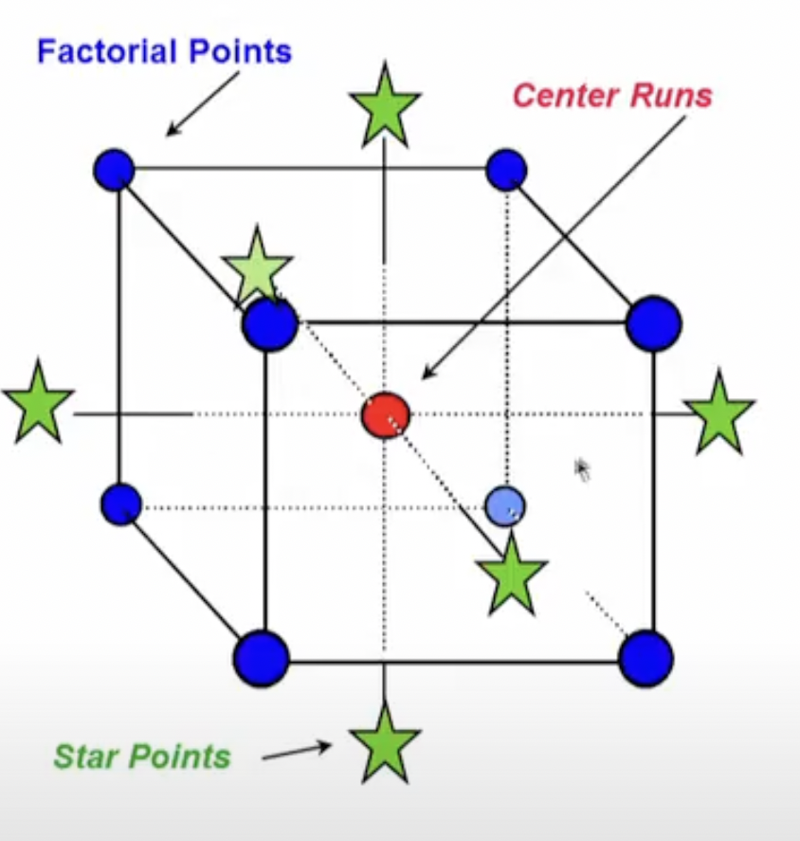

[**Figure 1:**](https://youtu.be/0cj3K5iwx4I?t=103) Selection of points in Box-Behnken method

1. Central Composite Design (CCD): Can evaluate three factors at five levels in a smaller number of experiments. Input variables are taken at the corner of the cube, plus center, plus on 6 faces slightly outside the cube. Mainly used for quantitative parameters. Estimates all linear, selected quadratics, and selected 2-way interaction plus the experimental error (we can tweak this in our case, if we are not interested in finding the experimental error).

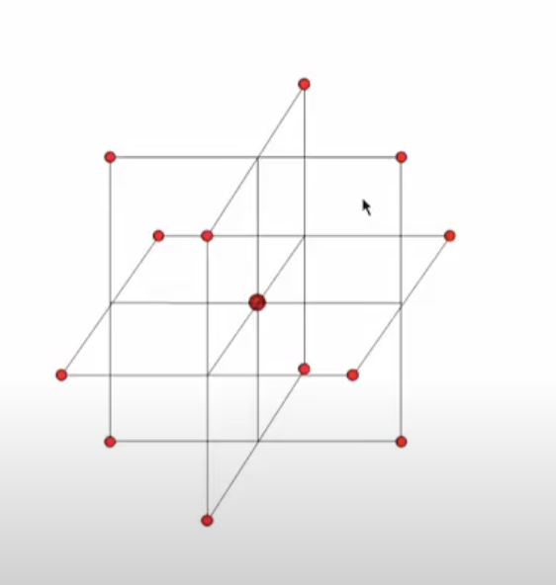

[**Figure2:**](https://youtu.be/0cj3K5iwx4I?t=149)Selection of points in CCD method

Typically, the best choice for quantitative factors.

1. Full factorial: Estimates all linear and quadratic relationships. Also, takes into consideration simple and higher order interactions. One of the BIG drawbacks of this approach is that it results in more experiments to run.

# Proposed methods for our study

From the above methods that has been illustrated for detailed study, these are the ones that are suited for our case:

1. CCD with 3 factors (each having five levels): Assuming that we can set five values for SOD. It would give us nice continuous space on the input variables and would also be more capable to capture more interactions.
2. CCD with 2 factors (each having five levels): Generate DOE for number of passes and speed and repeat this set for two values of SOD.
3. Full factorial: If we take 4 levels for number of passes, 4 for speed and 2 for SOD, the total number of experiments are 32. If we have the resources (which we have: 35 samples), this can be one of the best options. Only apprehension being ability to handle quantitative data for number of passes and speed.
4. Taguchi Array: Although, primarily a screening method but can be applied to our case. This has various tables for the different cases of input data you have. One of the standard tables [L16] aligns with our case.

# Comparison of proposed methods

|  | **CCD with 3 factors** | **CCD with 2 factors (#passes and speed)** | **Full factorial** | **Taguchi Design** |
| --- | --- | --- | --- | --- |
| **Runs** | 15 or 20 (if you want to evaluate experimental error as well) | 20 (we can also try random selection of the third variable and go with 10 runs) | 32 | 25 (#Parameters=3, Levels=5) |
| **Levels** | 5 for all the three parameters | 5 for #passes and speed and 2 for SOD | 4 for #passes and speed and 2 for SOD | 5 for all three parameters |
| **No. of qualitative factors | No. of quantitative factors** | 3 | 0 | 2 | 1 | - | 3 | 0 |
| **Comments** | Standard method, can deal with quantitative data. | Method tweaked for our convenience. We can reduce the #runs by randomizing. | Base Line. Most intuitive and Full Fledged. But deals with input parameters as sort of quantitative which is undesirable for #passes and speed. | Figure |

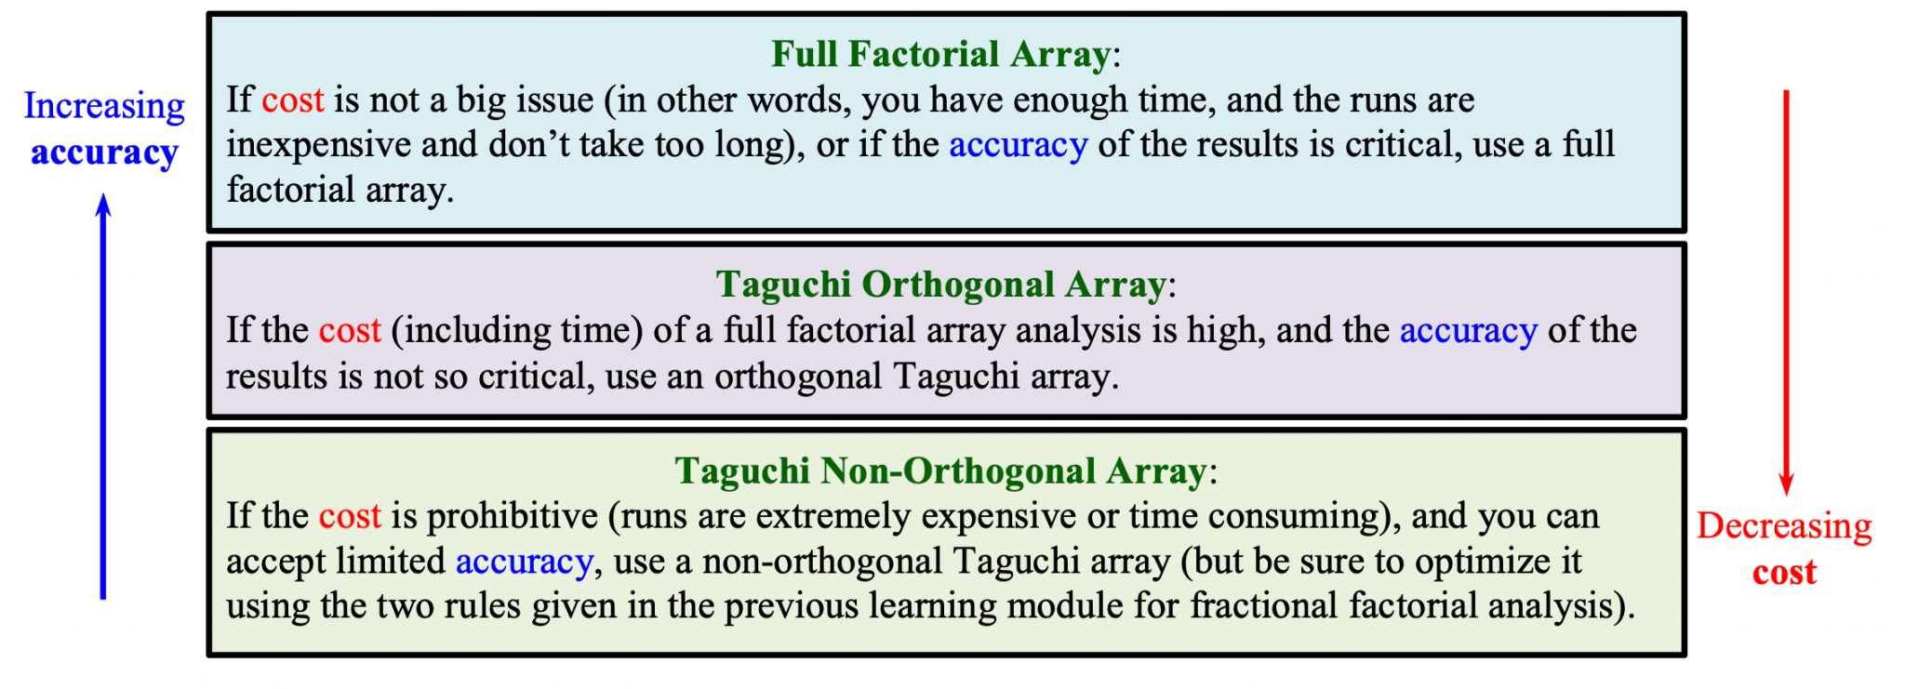

[**Figure 3:**](https://www.me.psu.edu/cimbala/me345/Lectures/Taguchi_orthogonal_arrays.pdf)Factors determining the choice of screening design.

# Results matrices

## 

| CCD with 3 factors (Generated from pyDOE2) | CCD with 2 factors (#passes and speed) (Generated from pyDOE2) |
| --- | --- |
|  |  |
| Full factorial (Generated from MATLAB) | [Taguchi Design](https://www.me.psu.edu/cimbala/me345/Lectures/Taguchi_orthogonal_arrays.pdf) |
|  |  |

## 

Where for #passes

Level 1 = (1+5)/2

Level 2 = (6+10)/2

Level 3 = (10+15)/2

Level 4 = (16+20)/2

Level 5 = (20+25)/2

And for speed

Level 1 = sqrt (1*5)/2

Level 2 = (4+7)/2

Level 3 = (7+10)/2

Level 4 = (10+13)/2

Level 5 = (13+15)/2

For SOD

Level 1 = 2

Level 2 = 5

Level 3 = 8

Level 4 = 11

Level 5 = 14

Once we concur on a final design, we can put some more thought into the scaling of -1, 0, +1, 1.76 to appropriate terms.

# Conclusion/Final Proposal

Choosing CCD for all the three factors with 5 levels seems to be the best option till now for the type of data we have. It gives us the appropriate amount of runs while increasing the levels in each factor. It is also the most popularly used method for detailed study. The only problem that we face with it is giving 5 levels for SOD, which can also be handled as mentioned above by doing CCD for just two variables and either randomly choosing SOD value or repeating the experiment for both binary values of SOD.

**Colab Link:** <https://colab.research.google.com/drive/1qiqYay3ZPf46tRAP3P3sy5aqTm1KNh2e?authuser=4#scrollTo=6zYeBwqEpTbb>

# 

# References

1. [Book - Statistics for Experimenters](https://pages.stat.wisc.edu/~yxu/Teaching/16%20spring%20Stat602/%5BGeorge_E._P._Box,_J._Stuart_Hunter,_William_G._Hu(BookZZ.org).pdf)
2. [NPTEL Course - Biostatistics and Design of Experiments](https://www.youtube.com/playlist?list=PLo4xQ9e-YcMkCDJrLo3GJ29rvCscVl_-4)
3. [Matlab Documentation on DOE](https://www.mathworks.com/help/stats/design-of-experiments-1.html?s_tid=CRUX_lftnav)
4. [Book - Design and analysis of experiments](https://industri.fatek.unpatti.ac.id/wp-content/uploads/2019/03/181-Design-and-Analysis-of-Experiments-Douglas-C.-Montgomery-Edisi-8-2013.pdf)
5. [PennState document on Taguchi Design](https://www.me.psu.edu/cimbala/me345/Lectures/Taguchi_orthogonal_arrays.pdf)